QUIZ - 5

Module – 05

Batch ID – JEE/CGNT-M/54/01

Exam Date – 16/07/2023

**Total Marks – 20**

**Student Name: Student ID:**

**1.Which of the following is not a good reason for constructing a requirements model?**

| **A)** | It can show the business situation in enough detail to check that the requirements have been captured fully and correctly. |
| --- | --- |
| **B)** | **It can demonstrate that all the use cases have been drawn using the correct notation** |
| **C)** | It can be organized in such a way that it will be useful later for designing the software |

**2. Which of the following statements best describes what a class diagram can include?**

| **A)** | Only classes |
| --- | --- |
| **B)** | Only classes and their relationships |
| **C)** | **Classes, instances and their relationships** |

**3. Which is the correct name for "a possible set of classes, together with an understanding of how those classes might interact to deliver the functionality of a use case?**

| **A)** | A use case class diagram |
| --- | --- |
| **B)** | A realization |
| **C)** | **A collaboration** |

**4.** 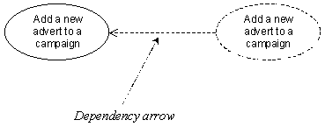

| **A)** | **It shows that elements within the collaboration (the dotted ellipse) may reference elements within the use case (the solid ellipse).** |
| --- | --- |
| **B)** | It shows that the collaboration (the dotted ellipse) cannot be implemented until the use case (the solid ellipse) has been implemented |
| **C)** | It shows the direction of the flow of control when the software executes |

**5. One of the following is not a difference between a class diagram and a collaboration diagram. Which one?**

| **A)** | A collaboration diagram shows object interaction, while a class diagram ignores this. |
| --- | --- |
| **B)** | A class diagram shows more of the structural details than the collaboration diagram |
| **C)** | **A class diagram shows the names of the classes, while the collaboration ignores these** |

**6. Which of these figures is a collaboration diagram?**

A) 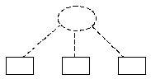 B) 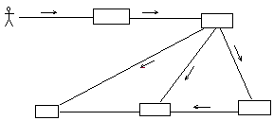 C) 

**ANS: Fig(B)**

**7. Which of these is the correct set of analysis class stereotypes in standard UML?**

| **A)** | Interface, control and entity |
| --- | --- |
| **B)** | **Boundary, control and entity** |
| **C)** | Interface, sequence and entity. |

**8. One of the following is not an advantage of stereotyping analysis classes. Which one?**

| **A)** | The resulting packages can form a basis for the system's architecture. |
| --- | --- |
| **B)** | It can be useful to differentiate classes that have broad similarities in the way that they behave. |
| **C)** | **Once a class is stereotyped, its behavior is likely to become more predictable** |

**9. What do boundary classes represent?**

| **A)** | Customers and suppliers of the business. |
| --- | --- |
| **B)** | People who will use the system. |
| **C)** | **Interaction between the system and its actors**. |

**10. What is the significance of the double colon in the class name: User Interface::AddAdvertUI?**

| **A)** | **The class called AddAdvertUI is in the package called User Interface.** |
| --- | --- |
| **B)** | User Interface is the stereotype of a class called AddAdvertUI |
| **C)** | User Interface and AddAdvertUI are two alternative names for the same class. |

**11. Which one of these is not a permitted symbol for a boundary class?**

A)  B) 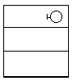 C) 

**ANS: FIG(A)**

**12. What are entity classes?**

| **A)** | Classes that contain data. |
| --- | --- |
| **B)** | Classes that contain persistent data. |
| **C)** | **Classes that represent something or some concept in the application domain** |

**13.**

| **One of these is not a permitted symbol for an entity class. Which one?** |
| --- |

A) 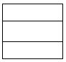 B) 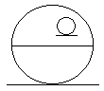 C) 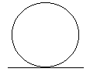

**ANS: Fig(B)**

**14. What do control classes represent?**

| **A)** | **The calculation and scheduling aspects of the logic of the use case** |
| --- | --- |
| **B)** | Classes that interact with the users of the system. |
| **C)** | Classes that control the storage of persistent data. |

**15. One of the following cannot directly affect the state of an object. Which one?**

| **A)** | A change in the value of one of its attributes |
| --- | --- |
| **B)** | **The creation or destruction of another object of the same class** |
| **C)** | The creation or destruction of a link with another object |

**16. What is the difference between a link and an association?**

| **A)** | **A link connects two instances, while an association connects two classes** |
| --- | --- |
| **B)** | A link is a transient association |
| | **C)** | A link is an association between two entity classes. | | --- | --- | | |

**17. What is the significance of the directional arrow indicated on this diagram?**

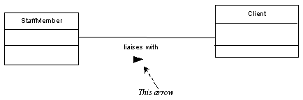

| **A)** | (A)It shows the direction in which you should read the name of the association |
| --- | --- |
| **B)** | (B)It shows the direction in which messages can be sent along the association |
| **C)** | (C)**It shows the order in which the objects will be connected when a link is created** |

**18. What is the significance of the multiplicity of an association?**

| **A)** | It denotes the number of different classes that can be linked together |
| --- | --- |
| **B)** | **It constrains the number of objects of one participating class that can be linked to an object of the other class** |
| **C)** | It constrains the number of times that an object of one participating class can be linked during its lifetime |

19. 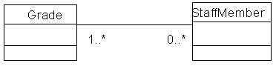

ANS:

| **A)** | A staff member need not be associated with any grades, or it can be associated with an indeterminate number of grades; a grade must be associated with one or more staff members |
| --- | --- |
| **B)** | A grade cannot be associated with a staff member but a staff member can be associated with a grade |
| **C)** | **A grade need not be associated with any staff members, or it can be associated with an indeterminate number of staff members; a staff member must be associated with one or more grades.** |

**20. How do operations differ from methods?**

| **A)** | **A method is a particular implementation of an operation** |
| --- | --- |
| **B)** | An operation is a particular implementation of a method. |
| **C)** | Some object-oriented programming languages have methods, while others have operations. |